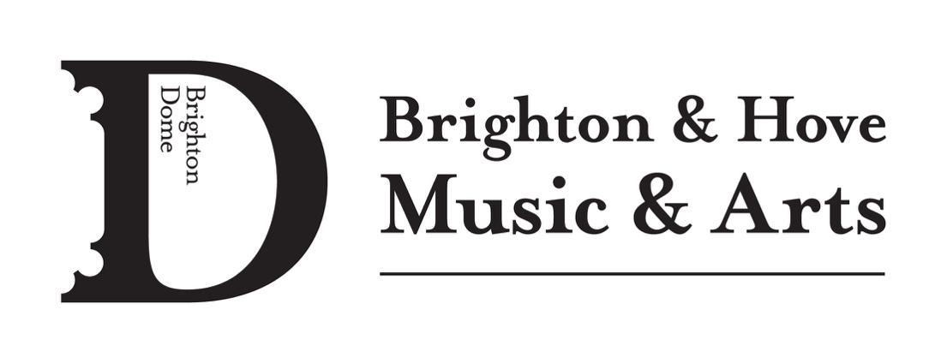
MEDIA RELEASE – PHOTOGRAPHY/FILM/RECORDING
From time to time Brighton & Hove Music & Arts (BHMA) may use photographs of activities (without names included) in printed publicity, our website, social media and other media, including YouTube/Vimeo.

Please complete the form below stating if you give permission for your child’s photograph, film or recording to be used:
PARENT/CARER NAME:______________________________________________
CHILD’s NAME:______________________________________________________
ACTIVITY NAME:_____ENCORE 5K FOR 500 FUNDRAISING CAMPAIGN

I give permission for my child’s photograph, film or recording to be used for this project.
YES NO

Parent/Carer Name: ____________________________ Date: ____________

Please return to bec.britain@icloud.com with the media being used in the campaign

